**St. Andrews**

**United Church**

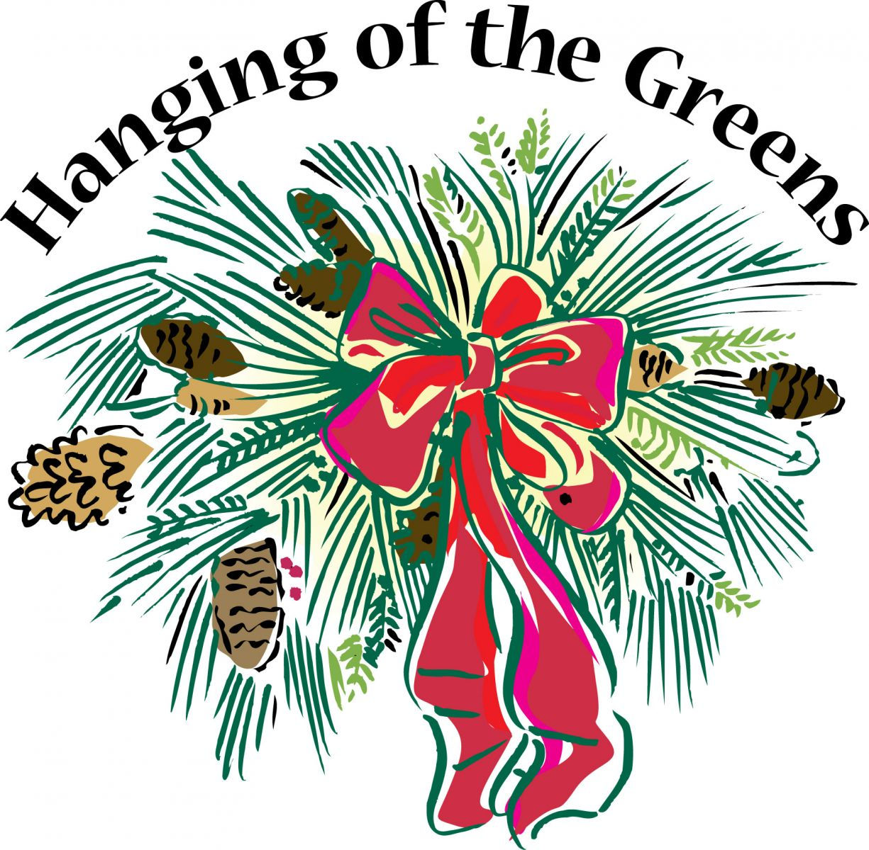

60 West Avenue, St. Thomas 519-631-4558

E-mail: [standrewsucgra@rogers.com](mailto:standrewsucgra@rogers.com)

Web site: [www.standrewsunitedchurch.com](http://www.standrewsunitedchurch.com/)

Ministers: The people of St. Andrew’s

Pastor: Rev. Cheryl Bolton

Ministry of Music: Merna Edison/

**Brian and Lynn Sloan**

**December 1, 2024 Hanging of the Greens**

**Prelude**

**Welcome & Announcements**

**Acknowledgement of Kinship**

**Advent Candle Lighting Liturgy**

**Advent 1: Hope**

A: As we light the candle of hope today

B: We make space for the grace of hope

A: We open our imperfect hearts to God’s Word

B: That hope will be rekindled in our lives

**All: Let us share God’s hope with our world.**

**Candle lighting Hymn - Prepare the Way of the Lord - 10 VU**

**Call to Worship**

One: November ends. December begins.

**All: We find our beginning and our ending in God.**

One: Month after month, our God attends us and supports us.

**All: For God’s company, we offer thanks and praise.**

One: Let us worship the God who gives us Jesus Christ:

**All: God who is the Alpha and the Omega, the beginning and the end, the Living One and our Redeemer, now and forever.**

**Reflection - Evergreens**

**Hymn -** Go Tell it on the Mountains - 43 VU

**Prayer**

**Reflection - Light in the Night**

**Hymn -** A Light is Gleaming - 82 VU

**Prayer**

**Reflection - Branch of Peace**

**Hymn -** Let There Be Light - 679 VU

**Prayer**

**Reflection - Wreath of Welcome**

**Hymn -** Come In, Come In and Sit Down 395 VU

**Prayer**

**Reflection - Bough of Love**

**Hymn** - O Perfect Love 491 VU

**Prayer**

**Ministry of Music**

**Meditation - Twas the Night Before Advent**

**Invitation to Offering**

**Offering Hymn - In the Bleak Midwinter - 55VU - Verse 4**

What can I give him, poor as I am

If I were a shepherd, I would bring a lamb

If I were a Wise man, I would do my part

Yet, What I can I give him - give my heart.

**Offering Prayer**

**A Minute for Celebration and Concerns**

**Prayers of the People**

**The Lord’s Prayer**

**Closing Hymn -** Hope is a Star - 7 VU

**Commissioning and Benediction**

**Announcements**

**Coming Events**

* **December 8th is White Gift Sunday. Please bring in socks, mitts, hats etc for Grace Café.**
* **December 4 Prayer Shawl 10:30am**
* **December 4 Advent Study at NVCC 12:30**



**UCW ladies will meet on December 10th at Boston Pizza for 11:30am.**

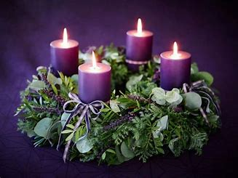 **Come and join Advent Study at New Vision Community church on Wednesdays at 12:30pm. Bring a lunch, come, enjoy some discussion and fellowship.**

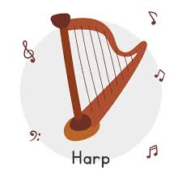

**Imagination a candlelight concert with harpist Jan Earnshaw on Saturday December 7, 2024 at 3:30pm. Location: New Vision Community Church at 38 Aldborough Ave., St. Thomas ON. Free will donation and light refreshments.**

 **Metcalfe Gardens Christmas Bazaar on Saturday Dec. 7th 9-1, at 45 Metcalfe Street. Variety of Vendors, Silent Auction, Raffle Table, Baked Goods and more. For more info. Call 519-631-9393**