**St. Andrews**

**United Church**



60 West Avenue, St. Thomas 519-631-4558

E-mail: [standrewsucgra@rogers.com](mailto:standrewsucgra@rogers.com)

Web site: [www.standrewsunitedchurch.com](http://www.standrewsunitedchurch.com/)

Ministers: The people of St. Andrew’s

Pastor: Rev. Cheryl Bolton

Ministry of Music: Merna Edison/

**Brian and Lynn Sloan**

**December 8, 2024 White Gift/Gifting Sunday**

**Prelude**

**Welcome & Announcements**

A voice cries out:

“Prepare for God’s arrival!

Make the road straight and smooth, a highway fit for our God.

Fill in the valleys, level off the hills.

Smooth out the ruts, and clear out the rocks.

For our God is coming!

Let’s worship together.

**Acknowledgement of Kinship**

As we gather in this time of expectant waiting, we begin by acknowledging the gifts we have already received and thanking Creator God, from whom all blessings flow, for this land on which we live and worship.  We acknowledge and give thanks to those who were stewards of the land before our ancestors came and we give thanks to them for the blessing of the sharing of this land. With open hearts we commit ourselves to living into Advent with peace and respect with all our relations.

**Advent Candle Lighting Liturgy**

A: As we light the candles of hope and peace today,

B: We make space for the grace of peace *(Light both candles).*

A: Abiding in God’s abundant grace,

B: We acknowledge the obstacles we face and sometimes create. Even so,

**All: Let us prepare the way of the Lord.**

**Candle lighting Hymn - Prepare the Way of the Lord - 10 VU**

**Opening Prayer**

The day of the Lord brings grace and blessing.

**We come to this day with hearts prepared for praising.**

The day of the Lord brings judgment and pardon.

**We come to this day with souls set on praying.**

The day of the Lord brings wisdom and light.

**We come to this day with minds eager to listen for God’s will.**

In our praising, praying, listening, and responding,

**we come to worship God.**

**Hymn - O Come, O Come Emmanuel - 1 VU**

**Prayer of Confession**

One: Merciful God, you offer us unending comfort and perfect peace, through Jesus Christ.

**Many: We confess that we have turned away from your unlimited grace, choosing instead to try to carry the weight of the world on our own frail shoulders.**

One: You offer us confidence and compassion, but we have chosen worry, nurturing fear over faith, and now we feel overwhelmed by our circumstances.

**Many: We are sorry, God. Please forgive us! Renew our minds as we embrace your peace.**

One: We now pause to prayerfully search our hearts, sharing with you those thoughts, words, and actions that we so deeply regret and no longer wish to carry *… (pause for silent confession).*

**Words of Assurance**

Siblings in Christ, receive this good news; in Jesus Christ, our peace is restored—peace with God, peace with one other, and peace in our own souls! As Luke 1:77–79 tells us, salvation is freely given to us by our compassionate God. Our failures, faults, and frailties are forgiven. The Prince of Peace eternally absorbs our human limitations and treats our finite vulnerabilities with infinite tenderness and grace. Thanks be to God, **Amen!**

**Reflection - White Gift or Giving Sunday**

**Hymn - Hark the Glad Sound - 29 VU**

**We Listen for God’s Word**

**Scripture Reading - Malachi 3: 1-4, Luke 3: 1-6**

**Ministry of Music**

**Meditation - Making a Straight Path**

**Hymn - There’s a Voice in the Wilderness - 18 VU**

**Invitation to Offering**

We all have gifts to give. Gifts of time, talent, or financial resources are offered and received with gratitude. As you prepare to present your offering for today, remember this: We do not give so that God will love us. We give *because* God loves us. Let us present our offering...

**Offering Hymn - In the Bleak Midwinter - 55VU - Verse 4**

What can I give him, poor as I am

If I were a shepherd, I would bring a lamb

If I were a Wise man, I would do my part

Yet, What I can I give him - give my heart.

**Offering Prayer -**

Generous God, with grateful hearts, we dedicate these gifts. May they be a blessing to many and a sign that the life and work of your church is ongoing. Multiply these gifts as we love and serve others, we pray, and help us to follow the peaceful example of Jesus, whose birth we eagerly await. Amen

**Prayers of the People -**

Prince of Peace, our world desperately needs to encounter the good news of your gospel.[1] Help us to “prepare the way of the Lord!” We pray boldly for the planet and all her peoples, asking for your peace to spread throughout creation like a virulent outbreak of contentment, infecting all peoples and places with the peace of Emmanuel, God-with-us! Cleanse humanity of our old hatreds and contemporary prejudices; remove our thirst for violence and our hunger for that which can never truly satisfy. Make space for grace in your world, O God, as we pray together for peace.

Prince of Peace, your global church also needs to encounter the good news of your gospel. Help us to “prepare the way of the Lord!” more faithfully. We pray boldly for your “capital-C Church,” the Body of Christ, asking for your peace to spread throughout every denomination and every congregation, until the peaceful presence of Emmanuel, God-with-us, erases our disdain and overcomes our animosities. Cleanse your Church of old hatreds and contemporary prejudices; remove our thirst for prideful certainties and our hunger for harsh judgments. Make space for grace in your Church, O God, as we pray together for peace.

Prince of Peace, our own community of faith, who desperately needs to encounter the good news of your gospel. Help us to “prepare the way of the Lord” more faithfully! We pray boldly for this congregation, asking for your peace to saturate our hearts, until the presence of Emmanuel, God-with-us, erases our ears and overcomes our resentments; bind us together in the hospitality of your love. Make space for grace in *this* church, O God, as we pray together for peace.

Prince of Peace, our families need to be changed by the good news of your gospel. Help us to “prepare the way of the Lord” more faithfully! We pray boldly for our families, naming our relatives and our chosen family and friends’ names aloud, or sharing them in the silence of our hearts (pause); spread your peace until the presence of Emmanuel, God-with-us, gives them true rest. Cleanse our families of the old hatreds, hurts, and hang-ups that have hindered peace; heal our generational harms and remove the contemporary prejudices that lead to further suffering. Make space for grace in our families, O God, as we pray together for peace.

One: Prince of Peace, we ourselves are in desperate need of your gospel good news. Help us to prepare for, and to accept “the way of the Lord!” We are not used to praying boldly on our own behalf, but we now ask for your peace. Saturate our souls, flood our hearts with the peaceful presence of Emmanuel, God-with-us. Cleanse us of old hatreds and contemporary prejudices; remove our unconscious ableism and release us from our endless rumination over our flaws, frailties, and failures. Make space for grace in our own lives, O God, as we pray together for peace.

One: Prince of Peace, we gather up our concerns before you now, using the prayer that Jesus taught his followers, saying together:

**The Lord’s Prayer**

**Closing Hymn - Good Christian Friends, Rejoice - 35 VU**

**Commissioning and Benediction**

May God, who has begun a good work within you,

continue that work until the day when Christ Jesus returns.

May your love overflow more and more;

may you continue to grow in knowledge and understanding,

so that you can clearly discern what really matters,

and so that you may stand pure and blameless before God

on the day of Christ’s return.

The God who calls you is faithful,

and He will do it.

Go in peace.

**Choral Amen**

**Announcements**

**Coming Events**

* **Euchre 1:30pm**
* **December 16th is Soup Collection for the Foodbank.**



**UCW ladies will meet on December 10th at Boston Pizza for 11:30am.**

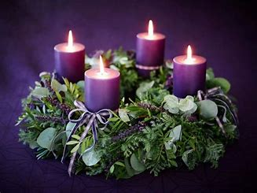 **Come and join Advent Study at New Vision Community church on Wednesdays at 12:30pm. Bring a lunch, come, enjoy some discussion and fellowship.**



**December 29th will be a combined service with New Vision. It will be a carol/hymn sing service and a potluck to follow.**

**December 24th Christmas Eve Service at St. Andrews at 5pm. Don’t miss this wonderful service with lots of musical offerings.**

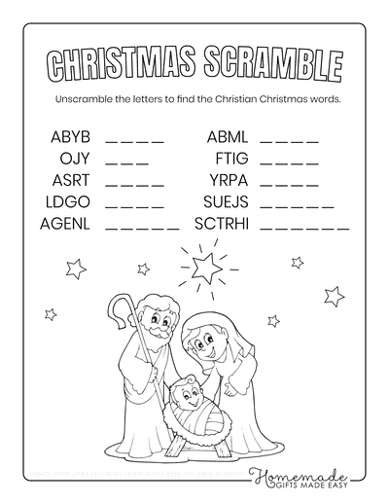

1.