**St. Andrews United**

**Church**

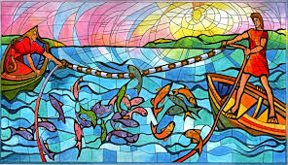

**60 West Avenue, St. Thomas 519-631-4558**

**E-mail:** [**standrewsucgra@rogers.com**](mailto:standrewsucgra@rogers.com)

**Web site:** [**www.standrewsunitedchurch.com**](http://www.standrewsunitedchurch.com/)

**Ministers: The people of St. Andrew’s**

**Pastor: Rev. Cheryl Bolton**

**Ministry of Music: Merna Edison**

**/Brian and Lynn Sloan**

**February 9th, 2025**

**WE GATHER**

**Welcome & Announcements**

**Acknowledging Our Kinship**

**Candle Lighting**

**Call To Worship**

One: We give thanks to God with our whole heart.

**All: Before God, we sing our praises.**

One: God is steadfast and faithful and answers our call.

**All: God increases the strength of our souls.**

One: Though we walk in the midst of trouble,

**All: God preserves us and stretches out a hand to help.**

One: We raise our own hands in praise and our voices in worship,

**All: for God’s steadfast love endures forever.**

One: So come, let us worship, give thanks and be joyful.

**Gathering Hymn - VU507 - Today we are called to be Disciples**

**Prayer of Confession**

One: God of unwavering love, you ask us to listen, but we try only to comprehend and control.

**All: You ask us to look, but we seek only to possess and underestimate what we see.**

One: Teach us how to move beyond looking with only our eyes, listening with only our ears, and learning with only our minds.

**All: Give us the ability to turn our hearts from the expected to the unexpected**

One: Help us to be healed not by what we can manage on our own but by what we can experience through your promise.

**All: Forgive our timid love and set us free to serve you we pray. Amen.**

Assurance of Pardon.

**Young at Heart**

**Hymn -VU567 - Will you come and follow me?**

**WE LISTEN FOR GOD’S WORD**

**Scripture Reading** : **Luke 5:1-11**.

**Sermon:** *Hook, Line and Sinker.*

**Hymn - VU345 - Come Children Join to sing.**

**RESPOND TO GOD’S WORD**

**Invitation to Offering**

**Offertory Hymn - Praise God, From Whom All Blessings**

***Praise God from whom all blessings flow;***

***praise God, all creatures high and low;***

***give thanks to God in love made known:***

***Creator, Word and Spirit, One.***

**Offering Prayer**

**Prayers of the People**

**The Lord’s Prayer**

**Closing Hymn - VU356 - Seek Ye First the Kingdom of God.**

**Commissioning and Benediction**

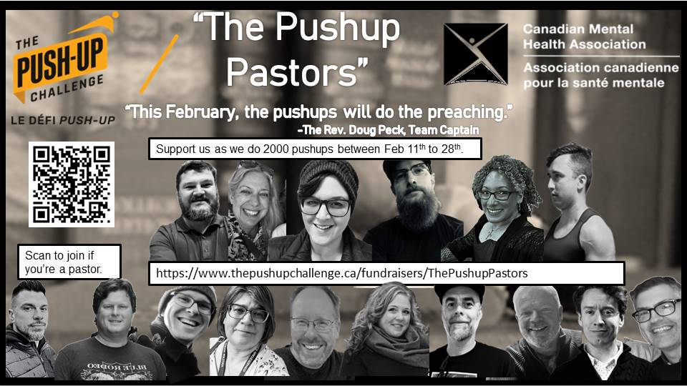

**Please consider supporting CMHA by sponsoring my colleagues &me as we do 2000 push ups each! The website for donations is :** [**www.thepushupchallenge.ca/fundraisers/ThePushupPastors**](http://www.thepushupchallenge.ca/fundraisers/ThePushupPastors)

***Announcements***

**Upcoming**

* **UCW Feb.11 at 10:30am**
* **Soup Luncheon 12-1pm in the hall**
* **Annual Meeting is March 2nd. Annual reports are now due. Please get them into the office or email**

*****The Foodbank item for February 16 is Soup!***

**There will be a Valentine’s Day Soup/Dessert luncheon at St.Andrews on Friday, February 14 from 12pm-1pm. Cost is $10. Tickets will be available by calling 519-615-2325. Make sure you save the date to come and enjoy a great lunch and some fellowship.**

**Special UCW project coming soon. The UCW will be making “Celebration Cake Kits” for the foodbank, so donations of cake mixes, ready-to-use icing, decorative sprinkles, birthday candles etc will be much appreciated. Keep an eye out for these items in flyers/sales in the coming weeks.**