**St. Andrews United**

**Church**

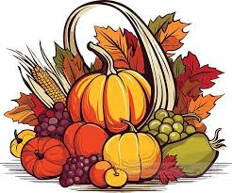

60 West Avenue, St. Thomas 519-631-4558

E-mail: [standrewsucgra@rogers.com](mailto:standrewsucgra@rogers.com)

Web site: [www.standrewsunitedchurch.com](http://www.standrewsunitedchurch.com/)

Ministers: The people of St. Andrew’s

Pastor: Rev. Cheryl Bolton

Ministry of Music: Brian and Lynn Sloan/

Merna Edison

October 13, 2024 Thanksgiving

**WE GATHER**

**Welcome**

**Announcements**

**Lighting the Christ Candle**

**Acknowledging Our Kinship**

One:For thousands of years, First Nations people have walked on this land; their relationship with the land is at the centre of their lives and spirituality. We are gathered on their traditional territory and acknowledge their stewardship of this land throughout the ages. Help us to become better neighbours so that we might live together in better ways.

**All: For we are all kin in Christ, “All My Relations,” with each other and this earth, its waters, air, animals, and plants.**

**Call to Worship**

One: God says, “I will fill your cup and then some.”

**All: We come now to receive.**

One: Jesus says, “I bring abundant life to all.”

**All: We come now to share.**

One: Spirit says, “I fill your hearts with love.”

**All: We come now to love.**

One: Let us worship God.

**Gathering Hymn - We Praise You O God - 218 VU**

**Prayer of Confession -**

**Assurance of Pardon**

**All God’s Children - Sharing is Caring**

**Hymn - Spirit, Spirit of Gentleness - 375 VU**

**WE LISTEN FOR GOD’S WORD**

**Scripture Reading - Psalm 126, Matthew 6: 25-33**

**Meditation - Don’t Worry, Be Happy**

**Hymn - O Lord My God - 238 VU**

**WE RESPOND TO GOD’S WORD**

**Invitation to Offering**

**Offering Hymn - For the Gift of Creation - 538 VU**

**Dedication -**

**Like the psalmist, gracious God, we love living with you and we are grateful for our many blessings. We love knowing that you are present with us as we journey through life. With thanksgiving in our hearts, we pray that our gifts of time, talent, and treasure will bless our neighbours, near and far. Amen.**

**A Moment for Concerns and Celebrations**

**Prayers of Thanksgiving and Concern**

**Lord’s Prayer**

**Hymn - We Are Marching - 646 VU**

**Blessing and Commissioning**

In the spirit of Thanksgiving,  
go into the world, this week,  
determined to share God’s lavish love with all whom you encounter. Go love God,  
go love yourselves, and go love others,  
knowing that God goes the way with you.  
**All: Thanks be to God!**

**Choral Amen**

**Announcements**

**Coming Events**

* **Prayer Shawl on Oct.16 at 10:30am**
* **Euchre on Oct. 17th at 1:30pm**

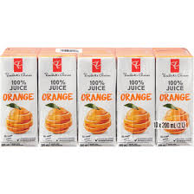

**Collection for Foodbank on October 20th is Juice Boxes..any kind, any flavour.**



**St. Andrews is having a Fall Craft show on November 16 and is looking for vendors. For information about table rental etc Please call Merna Edison at 519-615-2325.**

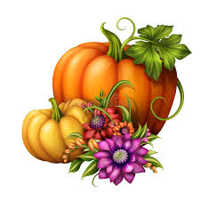Don’t forget the New Vision Fall Bounty Bazaar on November 2 from 9am-noon!